

ECONOMICS

Practice SAC 2.1.2-

UNIT 2 - OUTCOME 2

You will have 80 minutes to complete this task.

The SAC is a Structured Questions Test

The total SAC is worth 10% of your Unit 1 grade.

Conditions and restrictions
- Students are permitted to bring into the room for this task: pens, pencils, highlighters, erasers, sharpeners and rulers
- Students are NOT permitted to bring into the room for this task: blank sheets of paper and/or white out liquid/tape.

Materials supplied
- Question and answer book of 15 pages

Instructions
- Print your name in the space provided on the top of the front page.
- All written responses must be in English.

Student name ____________________________________________

Grade/Score: ____/___40 Satisfactory Completion? S/N: ______
(Provisional)
--------------------------------------------------------------------------------------
Assessment Criteria
This assessment task was developed using the Outcome 1 key knowledge and skills in Unit 2 VCE Economics:
Key knowledge

• the nature and meaning of trade-offs in economics
• aggregate demand and its components
• aggregate supply
• the meaning and measurement of economic growth using real Gross Domestic Product (GDP) and real GDP per capita
• the economic benefits of economic growth such as growth in material living standards, employment opportunities, economic development and non-material living standards
• the limitations associated with using GDP per capita to measure changes in living standards
• aggregate demand and aggregate supply factors that may influence economic growth
• factors that might affect future rates of economic growth such as an ageing population and labour force participation
• the meaning of both long-term economic prosperity and environmental sustainability
• economic and environmental costs of economic growth such as climate change, depletion of natural resources and deterioration of common access resources
• trade-offs and compatibility between economic growth and environmental sustainability
• alternative economic indicators of living standards
• the effect of policy response used to address environmental effects of economic growth such as market-based approaches, direct actions and regulation.

Key skills
• define key economic concepts and terms and use them appropriately
• access and synthesise information gathered from a range of sources and draw conclusions
• identify trends, patterns, similarities and differences in economic data and other information
• gather, interpret and analyse statistical and graphical data
• evaluate the potential costs and benefits associated with economic activity.

SECTION A – Multiple Choice
Instructions for Section A
Answer all questions.
Choose the response that is correct or that best answers the question.
A correct answer scores 1, an incorrect answer scores 0.
A mark will not be awarded if more than one response is chosen for a question.

Question 1
The total market value of all goods and services sold in Australia over a given period is a definition of:
- Gross Domestic Product
- National Income
- Consumer Price Index
- Gross National Expenditure

Question 2
A decrease in business productivity will have which of the following effects on the economy?
A. An increase in general prices, increase in real GDP and a decrease in unemployment
B. A decrease in general prices, increase in real GDP and a decrease in unemployment
C. An increase in general prices, a decrease in real GDP and an increase in unemployment
D. An decrease in general prices, a decrease in real GDP and an increase in unemployment

Question 3
An increase in consumer confidence should have which effect on the domestic economy in Australia?
A. Aggregate Demand curve should shift to the right, general prices should rise and real GDP growth should rise
B. Aggregate Demand curve should shift left, general prices should fall and real GDP growth should fall.
C. Aggregate Demand curve should shift right, general prices should fall and real GDP growth should rise
D. Aggregate Demand curve should shift left, general prices should fall, and real GDP growth should fall

Question 4
Which of the following is not an example of unsustainable development?
- Excessive burning of coal
- Overfishing in Australian waters
- Increased levels of deforestation
- Reduction in carbon emissions

Question 5
Which of the following measures is not designed to improve environmental outcomes?
- The reintroduction of a carbon tax
- Higher company taxes
- Direct action measures
- Environmental regulations

SECTION B – Written responses
Instructions for Section B
Answer all questions in the spaces provided.

Question 1 (6 marks)
a. Describe the trade-off between economic growth and environmental sustainability.
2 marks

b. Explain one direct and one market-based policy response used by the government to address the environmental effects of economic growth.
4 marks

Question 2 (5 marks)
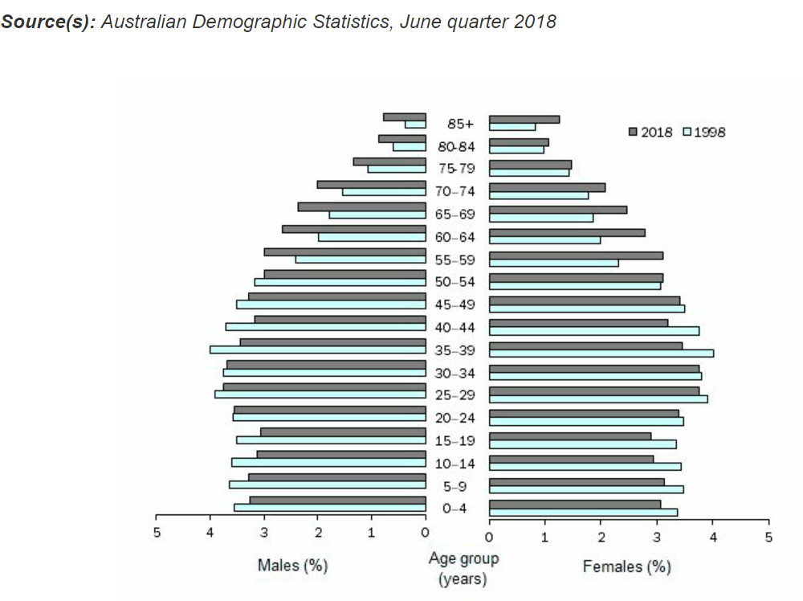

a. Describe the trend in Australia’s Ageing population over the past twenty years.
2 marks

b. Explain how the trend in Australia’s ageing population is likely to influence the aggregate supply curve and future rates of economic growth.
3 marks

Question 4 (8 marks)

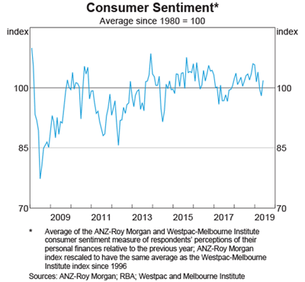
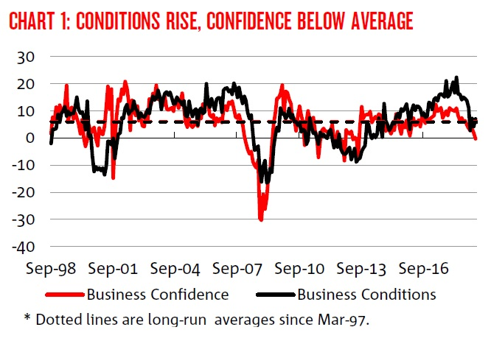

Analyse how the trend in both consumer confidence and business confidence is likely to influence the Aggregate Demand curve and:
- Economic growth
- Employment opportunities
- Living standards

Question 5 (6 marks)
The table below includes the chain volume of goods and services for Nation H over 2018 and 2019:
 | 2019 | 2020
Chain volume of goods and services | 100 | 104

a. Calculate the change in Real Gross Domestic Product over 2019 and 2020.
1 mark

b. Explain one economic benefit of economic growth.
2 marks

d. Explain the impact of a decline in economic growth on economic development and living standards.
3 marks

Question 6 (6 marks)
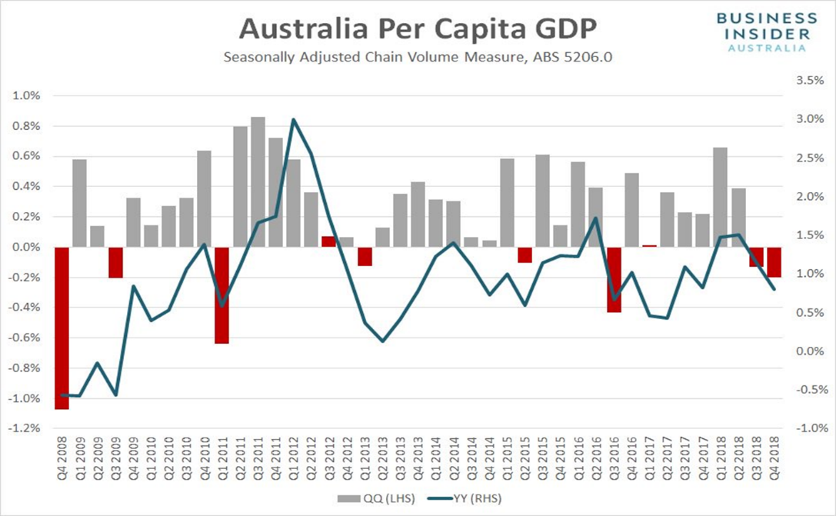
“Officially the two consecutive quarters of negative growth means that Australia has officially entered a GDP per capita recession”

a. Explain one reason that has influence the trend movement of Australia’s GDP per capita and the impact on material living standards.
2 marks

b. Explain one limitation of using real GDP per capita to measure living standards.
2 marks

d. Explain one alternative economic indicator to measure living standards.
2 marks

Extra writing space
(clearly label all responses)

